**Task 3: Predictive Analytics for Resource Allocation**

We used the Kaggle Breast Cancer Wisconsin dataset to simulate resource allocation via classification. A synthetic priority label was created based on tumor radius (a key feature), then predicted using a Random Forest Classifier. The model achieved strong accuracy and F1 score, suggesting it can support priority triage in resource-sensitive systems.

**Screenshot of confusion matrix**

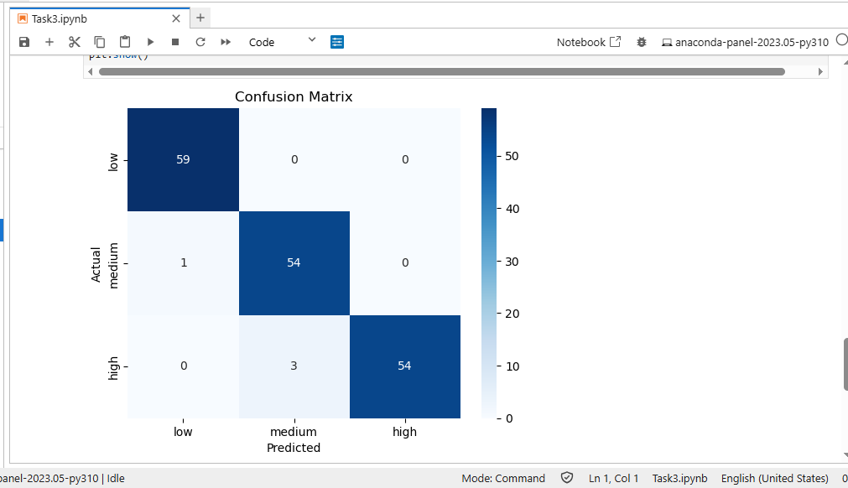

**Model performance metrics**

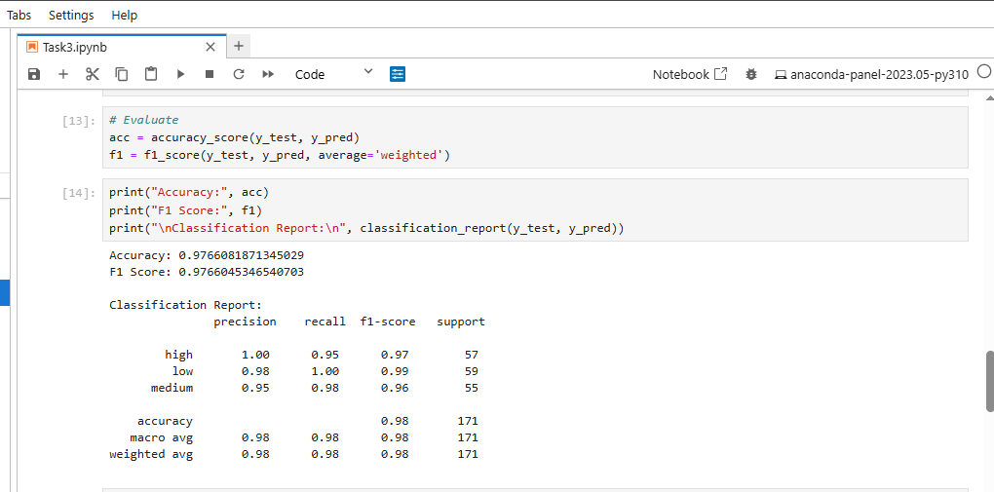

### **Ethical Reflection – Predictive Model Deployment**

Deploying the predictive model in a real-world company setting introduces several ethical concerns, primarily around **bias in data representation and outcomes**. The dataset used (Breast Cancer Wisconsin Diagnostic) is clean and numeric, but it may reflect systemic biases that become harmful when repurposed for other tasks like prioritizing issues or resource allocation.

For example, if the model is used to predict "issue priority" in an organizational setting, but the training data was based solely on tumor size (radius_mean), this could lead to **priority inflation for certain cases** and neglect of others that may be clinically or operationally urgent. Similarly, if the model is extended to real user or team data, and the dataset underrepresents specific groups (e.g., women in engineering, remote teams, or non-English speakers), the model may consistently **under-prioritize their issues**, reinforcing historical inequalities in technical support or triage systems.

To address these concerns, tools like **IBM AI Fairness 360 (AIF360)** can be integrated into the pipeline. AIF360 offers metrics to detect bias (e.g., disparate impact, statistical parity difference) and algorithms to mitigate it, such as reweighting, adversarial debiasing, or optimized preprocessing. By evaluating how different demographic groups are affected by predictions, developers can apply these techniques to ensure the model remains fair, inclusive, and compliant with ethical standards.

Ultimately, embedding fairness audits into the AI lifecycle ensures that automation promotes equity rather than amplifying bias.